The Dragon’s Egg

7. By the light of the egg, I pressed the button marked 7, and the lift started to judder down the shaft. When it came to a stop, the door opened onto a long tunnel illuminated by flickering candles.

“This way!” barked the fox, bounding forwards. “This way! We’ve got to get the egg back before it hatches, or we’ll really be in the soup!”
“Well, I said. “I suppose that would be strawberry soup, to go with the pink of your twirly tongue.”
“Don’t joke about it!” barked the fox. “It’s really not funny!”
“I suppose it isn’t,” I said, though I did think it was rather funny. “Is it much further? I really want to get home for my dinner.”
“Not far now,” barked the fox. “Just along here.”

As we moved down the corridor, I could feel the egg vibrating in my pocket, as if it were becoming more and more agitated. At the far end of the corridor was a huge portcullis. A golden glow came from the cavern beyond.

“At last,” I said. “Let’s get this over with.”
“Oh no!” barked the fox. “Oh no! The portcullis won’t just open. You’ve got to unlock it.”
“Come on!” I said. “This is getting ridiculous! Can’t we just give the egg to someone?”
“No!” barked the fox. “No! You’ve got to return it.”
“How do we open the portcullis then?” I said.
“There’s a lock, of course,” barked the fox. “Have a look.”

In the centre of the portcullis was a big bronze square. Within this square were eight smaller bronze squares. Each of these squares had a number on it:

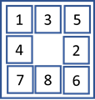 (A)

“How does this work?” I said.
“You got to rearrange the squares so they go from one to eight,” barked the fox. “Like this”.

The fox drew a diagram on the ground with his left front paw:

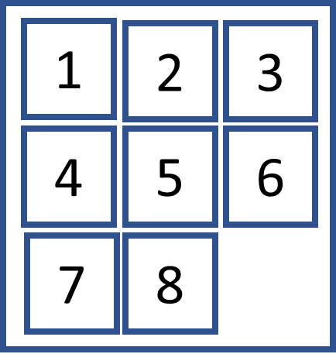 (G)

“Well let’s just take them out and put them back in the right order,” I said.
“Oh no!” barked the fox. “Oh no! You can’t do that. You’ve got to slide the squares into position.”
“But there must be hundreds of combinations!” I said.
“Thousand!” barked the fox.
“Can I use the egg?” I said.
“You can try,” barked the fox. “But’s it’s very fresh.”

I held up the egg to the gate. Out of the egg popped two eyes on the end of bendy stalks. The stalks scanned the lock. Then they twisted round and shone rainbow shafts onto the ground, carving out patterns:

(B) | (C) | (D) | (E) | (F)
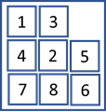 | 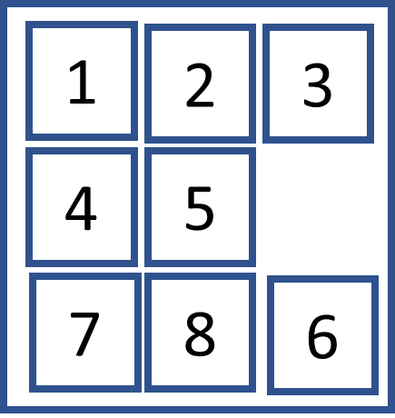 | 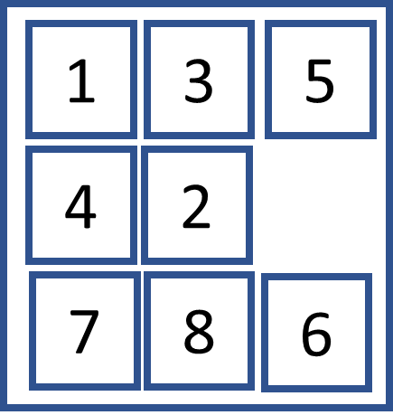 | 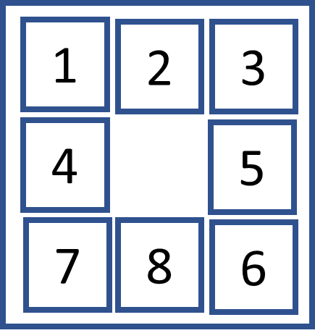 | 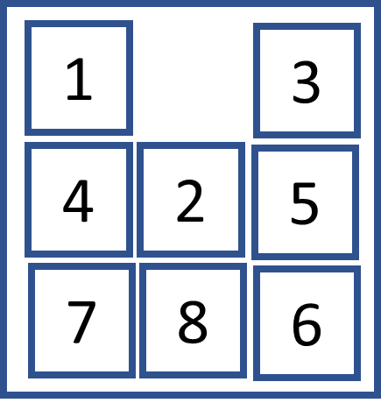

“That’s not a lot of help,” I said. “They’re in the wrong order.”
“I told you the egg was fresh,” barked the fox.

I sighed, took out my mobile phone, and called Nancy.

“Start with final answer,” said Nancy. “And work backwards.” And put the phone down.

